Jeremy Neiman

R Challenge #1

Summary of Subscribers and Customers with and without Outliers
 | Count | Min | 1st Qu. | Median | Mean | 3rd. Qu | Max | σ
Subscribers | 279924 | 60 | 332 | 498 | 635.5 | 757 | 43020 | 848.48
Subscribers (w/o Outliers) | 278972 | 60 | 331 | 497 | 605.3 | 753 | 3179 | 405.22
Customers | 5628 | 60 | 684 | 1148 | 1589 | 1717 | 40660 | 2114.28
Customers  (w/o Outliers) | 5544 | 60 | 679 | 1129 | 1401 | 1689 | 7931 | 1142.76

Most rides for subscribers fall within 5-10 minutes and 10-20 minutes for customers. The data is skewed right, with no outliers on the low end and a small number of outliers far to the right. The outliers are so few in number that they don't have a large effect on the mean/median, but they about double the standard deviation and move the maximum values out to 5-14 times greater.

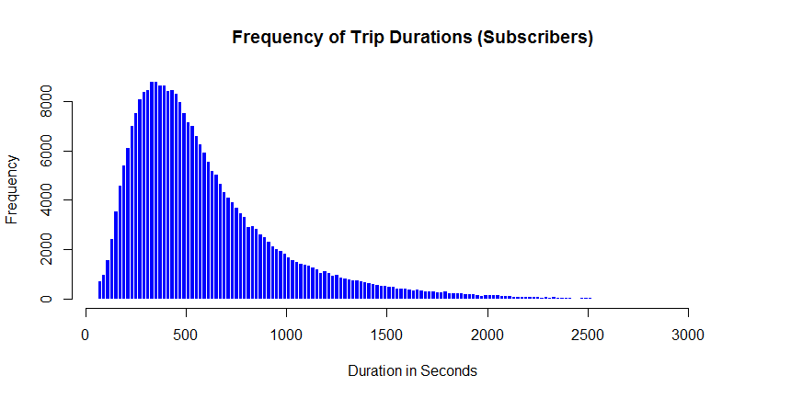
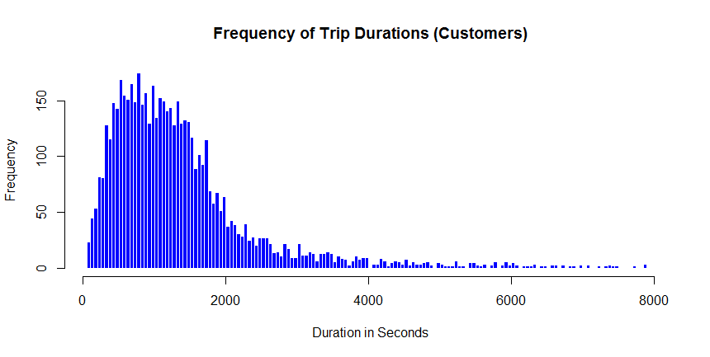

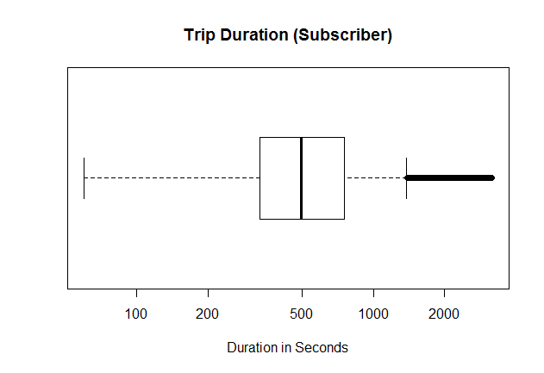
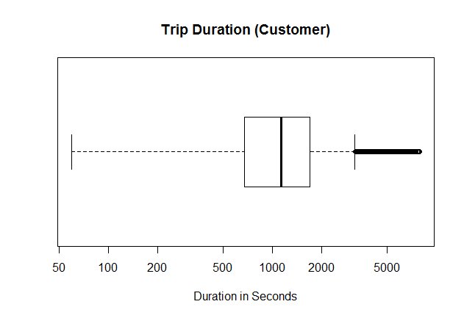
Outliers make it much more difficult to visualize detail in histograms and box plots. If the plots need to accommodate the whole data range, then the bulk of the data will be squashed into one small part of the plot. A histogram with the outliers would have most of the data squashed together in the same bins on the left, while most of the rest of the plot would be largely empty.

